Subsystem title: Purchasing

# ERD for UX process

Place your ERD diagram here.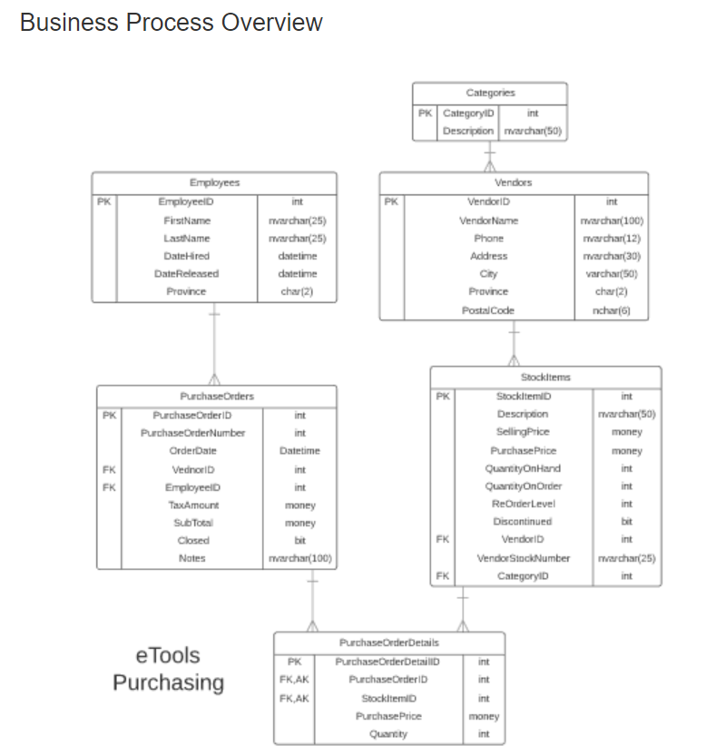

Possible UX Interface

Place your screen design(s) here:

|  |  |  |
| --- | --- | --- |
| **Controls** | | **Events** |
| Fetch (Vendor, PurchaseOrders, PurchaseorderDetails),StockItems, SearchArgID | | OnClick / wired via ObjectDataSource   * Move selection value to ItemsBy, DDL id to SearchArgID; * Bind data to StockItems   OnCommand   * Collect StockItems information and validate * Send to BLL for adding PurchaseOrderDetails and PurchaseOrder records to PurchaseOrderDetails * Refresh PurchaseOrderDetails |
| **BBL Class(es) and Method (s)** | | |
| StockItemsController, | ● List< StockItemsList >List_StockItemsForNewSuggestedOrder(argid)  Create new orderlist. Return stockItemId, description, quantityonhand, quantityonorder, reorderlevel, quantityonorder, Price. Display in New Suggested Order.  ● List< VendorStockItemsList >List_StockItemsForNewSuggestedOrder(argid)  Create new order. Return stockItemId, description, quantityonhand, quantityonorder, reorderlevel, buffer, Price. Display in New Suggested Order.  ● List< StockItemsList > List_StockItemsForCurrentActiveOrder (string itemsby, argid)  Retrieve a list of CurrentActiveOrder for Placing Orders. Return stockItemId, description, quantityonhand, quantityonorder, reorderlevel, quantitytoorder, Price. Display in Current Active Order.  ● List< VendorStockItems > List_VendorStockItemsForCurrentActiveOrder (string itemsby, argid)  Retrieve a list of VendorStockItems for Adding to current orders. Return stockItemId, description, quantityonhand, quantityonorder, reorderlevel, buffer, Price. Display in Vendor StockItems. | |
| **SQL Table(s): (C,R,U,D)** | | **Entities/DTOs/POCOs** |
| StockItems (R), PurchaseOrderDetails(C) | | StockItemsList(P), PurchaseOrderDetailslist(p) |

|  |  |  |
| --- | --- | --- |
| **Controls** | | **Events** |
| VendorDDL | | None / wired via ObjectDataSource |
| **BBL Class(es) and Method (s)** | | |
| VendorContoller | List< SelectionVendorlist > List_VendorName()  Retrieve a list of vendor name and vendor id for DDL | |
| **SQL Table(s): (C,R,U,D)** | | **Entities/DTOs/POCOs** |
| Vendors(R) | | SelectionList (P) |

|  |  |  |
| --- | --- | --- |
| **Controls** | | **Events** |
| Remove, lineItems | | OnClick   * Collect line Item and purchseorderId and purchaseorderDetailsiId and validate * Send to BLL for removing line Item from purchase order * Refresh current Active purchase order |
| **BBL Class(es) and Method (s)** | | |
| PurchaseorderdetailsController | Void Remove_CurrentActivePurchaseOrdderlist ()  TRX (find item, remove item, shift remaining item’s lines up, renumber Item’s line). | |
| **SQL Table(s): (C,R,U,D)** | | **Entities/DTOs/POCOs** |
| StockItems(R), purchseOrderDetails(U/D) | |  |

|  |  |  |
| --- | --- | --- |
| **Controls** | | **Events** |
| Add( lineItems), VendorStockItems | | OnClick   * Collect line Item and purchaseorderDetailsiId and validate * Send to BLL for adding line Item to current active order * Refresh current Active purchase order |
| **BBL Class(es) and Method (s)** | | |
| PurchaseorderController, | Void Add_LinItemToCurrentActivePurchaseOrdderList ()  TRX (Add items to current open order qty 1) | |
| **SQL Table(s): (C,R,U,D)** | | **Entities/DTOs/POCOs** |
| StockItems(R), purchaseOrder(C) | | CurrentActivePurchaseOrder(p) |

|  |  |  |
| --- | --- | --- |
| **Controls** | | **Events** |
| Update (CurrentActiveOrder) | | wired via ObjectDataSource   * Collect line items and edit rows to modify desired rows( QTO, Price) * Refresh current Active purchase order |
| **BBL Class(es) and Method (s)** | | |
| StockItemsController | ● List< StockItemsList > List_UpdateStockItemsForCurrentActiveOrder() | |
| **SQL Table(s): (C,R,U,D)** | | **Entities/DTOs/POCOs** |
| StockLineItems (R) | | CurrentActivePurchaseOrder(p) |

|  |  |  |
| --- | --- | --- |
| **Controls** | | **Events** |
| Place(CurrentActivePurchaseOrder), | | Save OnClick   * Collect line Items from Active Purchase order and set the OrderDate and PurhcaseOrderNumber to currentActiveOrder * Update the quantityonorder for StockItems on Purchase Order * Send to BLL to finalize for Vendor * Refresh PurchaseOrders |
| **BBL Class(es) and Method (s)** | | |
| PurchaseorderController | * Void Add_ToPurchaseOrder( datetime orderdate, int purchaseordernumber)   TRX( set the datetime to current date, add purchaseordernumber to PurchaseOrders)   * Void Update_StockItems( int quantityonorder, list< CurrentActiveOrder> quantiyonorder)   TRX( match incoming quantityonorder to existing quantityonorder, update differences) | |
| **SQL Table(s): (C,R,U,D)** | | **Entities/DTOs/POCOs** |
| StockLineItems (U), PurchaseOrders(C,U) | | CurrentActivePurchaseOrder(p) |

|  |  |  |
| --- | --- | --- |
| **Controls** | | **Events** |
| Delete, CurrentActivePurchaseOrder, PurchaseOrderDetails | | OnClick   * Collect purchaseorderid, stockitem, * Send to BLL for removing from system |
| **BBL Class(es) and Method (s)** | | |
| PurchaseorderController | Void Delete_CurrentOpenPurchaseOrder() | |
| **SQL Table(s): (C,R,U,D)** | | **Entities/DTOs/POCOs** |
| PurchaseOrderDetails(U/D), PurchaseOrder(R) | |  |

|  |  |  |
| --- | --- | --- |
| **Controls** | | **Events** |
| Clear, CurrentActivePurchaseOrder | | OnClick   * Collect information from current active order and clear web page * Reset vendor list to show prompt to select vendor |
| **BBL Class(es) and Method (s)** | | |
| PurchaseorderController | Void Clear_ CurrentOpenPurchaseOrder()  Void Clear_List<SelectionVendorlist> List_VendorName() | |
| **SQL Table(s): (C,R,U,D)** | | **Entities/DTOs/POCOs** |
|  | |  |